**CSC 210 – OOP II LAB 5**

1. Write a Java program to produce the GUI below. Do not include any functionality at this stage.

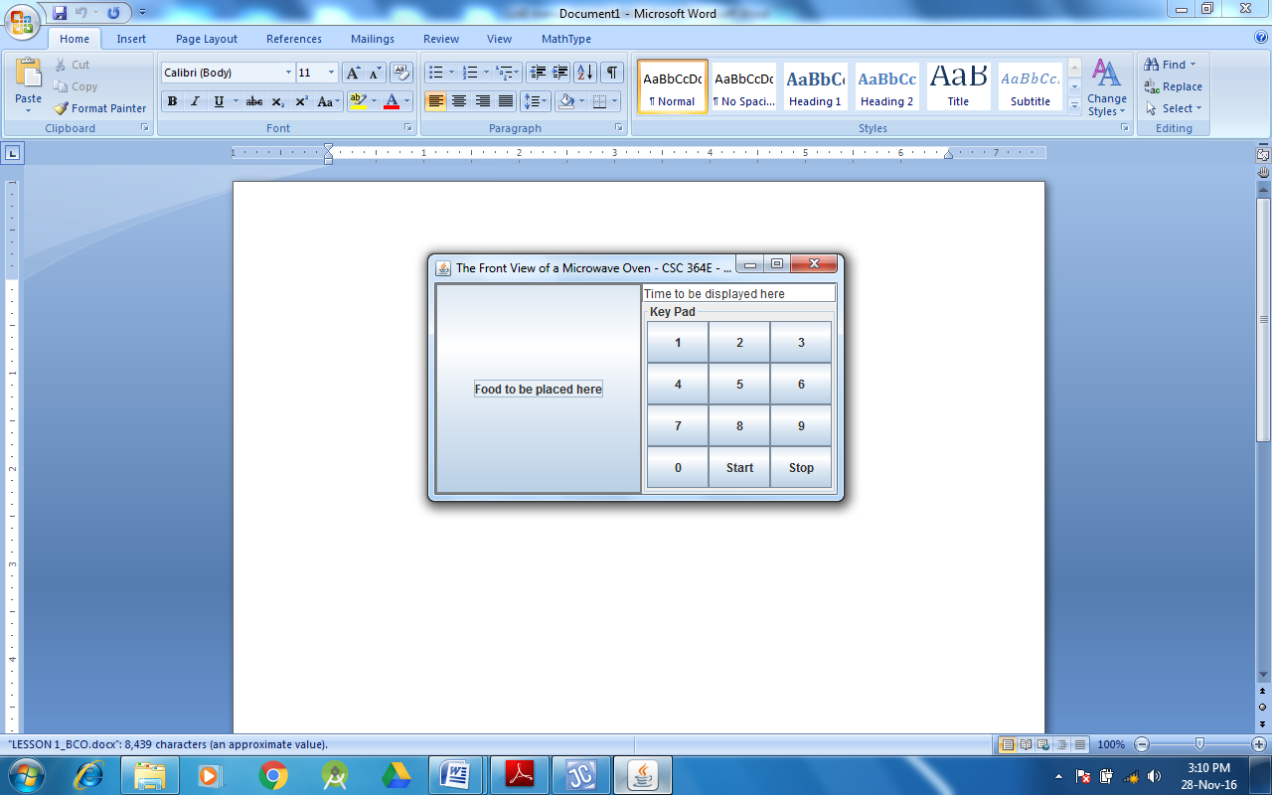

1. The goal of this lab is to create a GUI window like the one displayed below. Pressing any of the keys on the key panel one should be able to compose a password (that will be evidenced by the progression of ‘*’ in the appropriate field) that can then be displayed by clicking the Show key. Clicking C will imply canceling the current password and should result in clearing all the ‘*’ characters and the eventual password displayed. It should not be possible to change manually the asterisked field nor the password field. An illustration of the swing components used is shown below:

